Patagonia’s Noelia invites you to Sponsor an Alpaca from Sawdust Alpacas, LLC  
 SawdustAlpacas.com

**Sawdust Alpacas, LLC Sponsorship Program**

Would you like to own an alpaca? Don’t have a farm or property where you can keep a few? (They are herd animals so need at least two.) Don’t have the time or expertise to care for an alpaca? Miss Noelia (Noel) says “NOW YOU CAN”. At Sawdust Alpacas, LLC we have a way to fulfill your dream of having an alpaca without the commitment, investment and all the hard work that owning alpacas require.

Sawdust Alpacas, LLC has several alpacas chosen for this program. Noel thinks one is sure to be your favorite. Of course, if you loved one not shown below, please let us know and we can make your chosen alpaca sponsorable.

Your sponsorship can be for 6 months or 1 year. Please note, the chosen alpaca will remain on our ranch and will continue to be our ownership. Your sponsorship fee will help keep your favorite alpaca well fed and cared for. This includes feed (hay and mineral pellets), shearing fees, general husbandry (teeth & toes trimmed, yearly booster shots) and veterinary care if needed. We are offering a Six-Month sponsorship at $175.00 and a One Year Sponsorship program at $250.00.

**What do you get for your 6 Month Sponsorship Fee** of $175.00

1. An emailed copy of your sponsorship Certificate
2. An emailed copy of your chosen alpaca’s registration certificate from Alpaca Owners Association. A digital, frameable picture of your sponsored alpaca (if you are not able to take one at the time of sponsorship)
3. If you are in the area, monthly visits with your alpaca (a $300.00 value) by appointment. If not in the area, we will send you an update or pictures every 6 to 8 weeks.

**What’s included in the 1 Year Sponsorship Fee** **Of $250.00?**

All of the above items and

1. A sample of your alpaca’s fiber at shearing
2. **10% discount on any items purchased in our store or online during your yearlong sponsorship (you could very easily recoup your initial investment.)**

**How to Sponsor an Alpaca**

Visit Sawdust Alpacas, LLC in person or online at [www.sawdustalpacas.com](http://www.sawdustalpacas.com)

* Select your Favorite Alpaca
* Complete the attached registration form.
* **Complete your Sponsorship purchase thru the store, in person or online.**
* Upon receipt for your registration form and payment, your Sponsorship Package will be prepared and emailed to you.
* If sponsorship is completed online, please fill out the form and email it to us. For some reason, the form does not show up on the payment site so we don’t know who you want to sponsor. Thanks.

**Disclaimer:**

Your participation in the sponsorship program will help us continue to ensure that your sponsored alpaca and his/her pen mates enjoy their life to the fullest. Your contribution is NON-REFUNDABLE and does not constitute ownership of the alpaca. Please understand that another person may also sponsor the same alpaca as you.

At Sawdust Alpacas, LLC we are committed to providing the best feed, mineral supplements, and general care available for all our alpacas. If your selected alpaca is removed from the herd, for any reason, during your sponsorship period, you will be able to choose another alpaca for the duration of your sponsorship period.

MISS Noelia says “**Thanks for your support**” as do we here at Sawdust Alpacas, LLC.

**Sawdust Alpacas, LLC Alpaca Sponsorship Registration Form**

General Instructions

The person who will be the Sponsor parent is the Sponsor.

If you are giving the sponsorship as a gift, please include your name and address as well as the name and address of the gift recipient (Sponsor)

Is this a gift sponsorship: Y N If yes, please provide the following:

Your Name ______________________________________________________________

Your Email address: ______________________________________________________________

Your Phone Number: ______________________________________________________________

**Person Receiving the Sponsorship:**

Name: ______________________________________________________________________

Street Address: ______________________________________________________________________

City: ______________________________________________________________________

State/Province_____________________________ Zip Code _________________

Telephone Number____________________________

Email Address:

______________________________________________________________________

Birthdate: _________________________________________________________________

Name of the alpaca to be sponsored_________________________________

Please include any comments, special instructions, or questions:

**___________________________________________________________________**

**___________________________________________________________________**

**___________________________________________________________________**

**Alpacas in our Sponsorship Program**

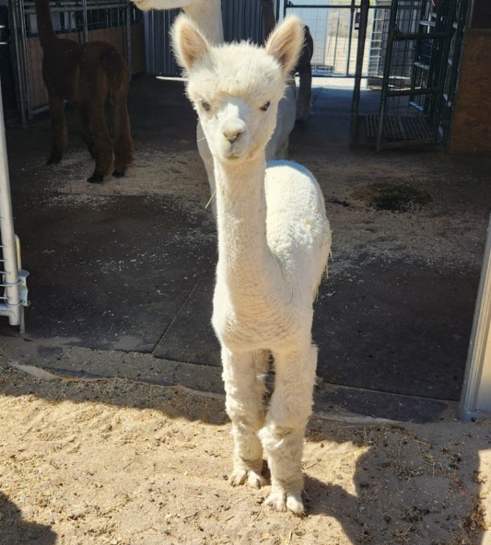

Sawdust’s Tulip

DOB: 9/24/23

ARI # 35082231

Dam: Sawdust’s Kali

Sire: Vintage Cashmere’s U-Taupe-ia

Miss Tulip is our only girl born in 2023. She has had a little bit of a struggle since first time Mom does not have much milk. We have had to bottle feed and supplement for awhile. She is a very active cria though and doing well. We are so happy to have Miss Tulip in the herd!.

Check her out online. Better yet, come meet her in person!

[www.sawdustalpacas.com](http://www.sawdustalpacas.com)

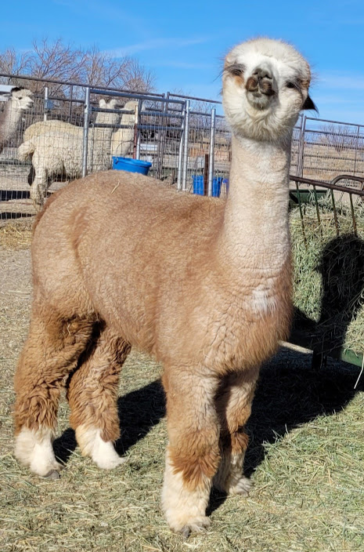

MBLF Chaka Khan

DOB: 07/02/2015

ARI # 35308102

Dam: Crescent Moon’s Chellita

Sire: Snowmass Enlightenment

What a character Miss Chaka Khan is! Can’t you just see it in her face?

Chaka Khan is mom to our Harvest Host mascot, JC’s Nambar (AKA Harvest Host HaRVey) Both mom and son are beautiful Alpacas!

Chaka Khan would love to have you as her sponsor. Check her out on our website at [www.sawdustalpacas.com](http://www.sawdustalpacas.com) where you will also be able to sponsor her.

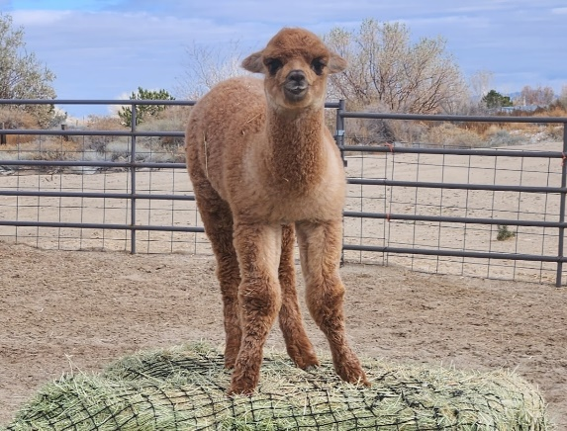

Sawdust’s Albizia (AKA Moose)

DOB: 10/04/23

ARI # 36290222

Dam: Snow Diamond Felicity

Sire: Sawdust’s High Cotton

Albizia thinks he owns this bale of hay, obviously. Born 10/4/23, he is already over 40 lbs. Come meet him today. Review and Sponsor at

[www.sawdustalpacas.com](http://www.sawdustalpacas.com)

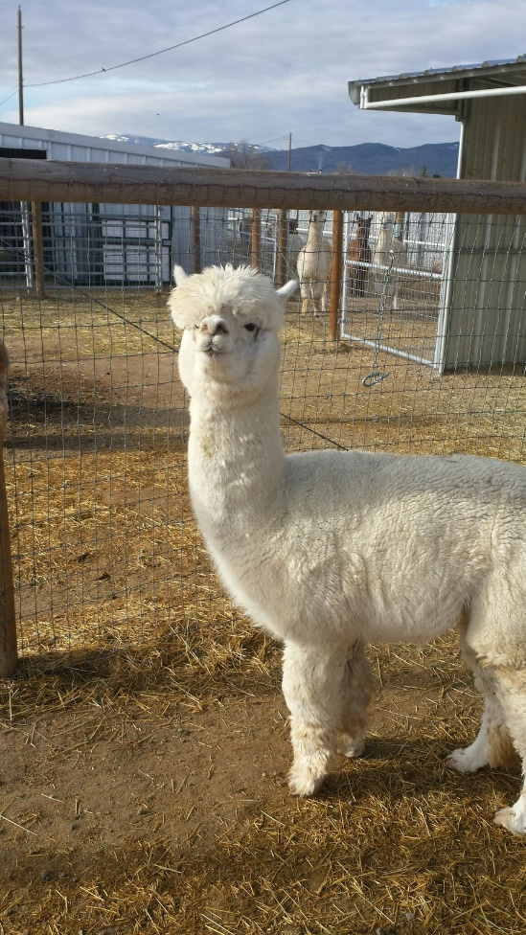

Immanuel Cuervo Plateado

DOB: 07/02/2007

ARI # 30426672

Dam: Peruvian Dulce

Sire: MFI Brock

**Just call me Mr. Attitude**

Cuervo is the oldest male on our property right now. We have watched his growth and achievements since he was 3 years old. He has been a great herdsire for us. He is beginning to show his age tho. So, your sponsorship will provide the extra support he needs as he ages.

You can find and pay for a sponsorship application in person, or online at [www.sawdustalpacas.com](http://www.sawdustalpacas.com).

